**Database System Practical 5**

**Tables:**

**Client Master**

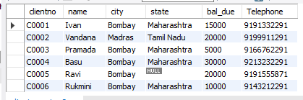

**Product Master**

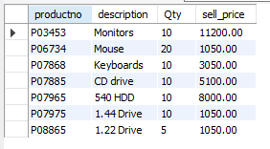

**Q1: Count the total number of orders placed.**

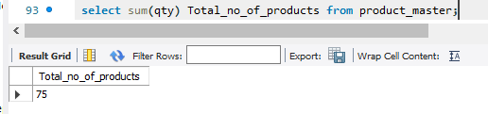

**Q2: Calculate the average price of all the products.**

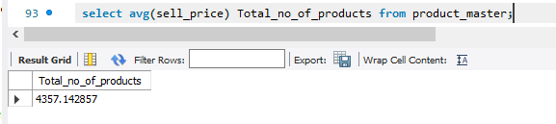

**Q3: Determine the maximum and minimum product prices.**

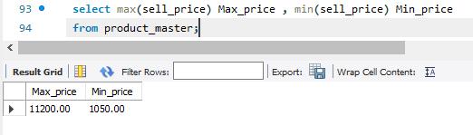

**Q4:Count the number of products having price greater then equal to 1500.**

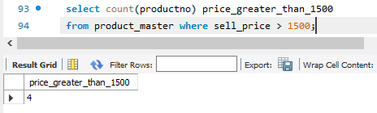

**Q5: Find all the product whose quantity is less than 50.**

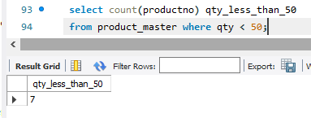

**Q6: Retrieve the city of all clients in lower case letters.**

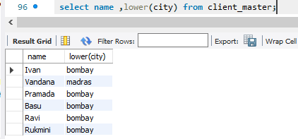

**Q8: Display the state of client no C0002 in upper case.**

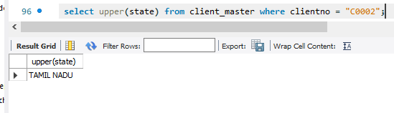

**Q9: Retrieve the city of client by extracting substring from the city column with m=1, n=4.**

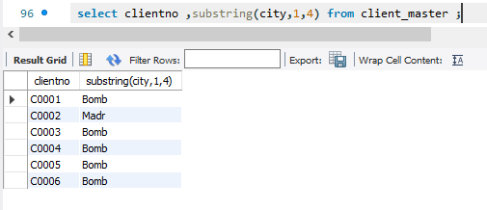

**Q10: Calculate the length of names of clients having client_no=C0004.**

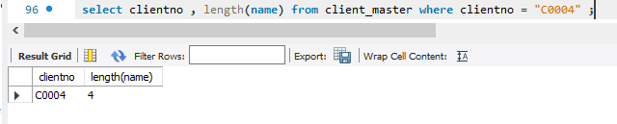

**Q11: Update the table product by adding Rs 1000 to the sell price of all products.**

